Trump’s Wiretap Distraction
By George Lakoff
The net has been drawing closer around Trump’s Russian connections. His unwavering support for America’s major enemy has raised a question: Is Treason the Reason? The Tax Return issue has become a treason issue. The tax returns would show if he is deeply in debt to Russians or if he is involved in illegal financial activity. He could clear suspicions by releasing the returns. The longer he refuses to do so, the greater the suspicion gets. Jeff Sessions recusal made Trump furious, because it meant that Sessions could no longer protect him from an independent Justice Department investigation, if there were to be one. Id Sessions is forced to resign, the net get that much tighter.
In the midst of this, Trump created a distraction: Accusing Obama of wiretapping the Trump Tower, with no evidence. Faced with the biggest scandal in American history, presidential treason, Trump, with a tweet, accuses Obama of a scandal bigger that Watergate.
Trump’s tweets are strategic. Here is a diagram of his tweet strategies:
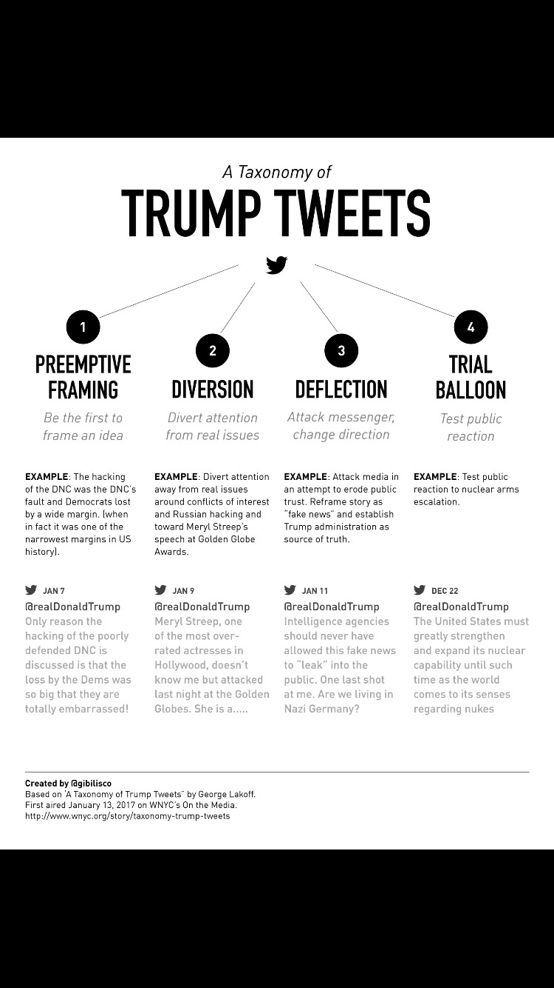

I analyzed the tweets on NPR’s On the Media, and the diagram appeared in the Washington Post, on March 6, 2017.
https://www.washingtonpost.com/news/worldviews/wp/2017/03/06/trumps-twitter-feed-is-a-gateway-to-authoritarianism/?utm_term=.73d8cc9a525f
Trump’s tweet is a doozy: It is an instance of all four of Trump’s strategies.
Pre-emptive Framing: He frames first: the presidential scandal is Obama’s wiretapping — an accusation without evidence and with all evidence against it.
Deflection: Put the onus on his squeaky-clean predecessor.
Trail Balloon: Will the public accept it, or listen to a discussion of it long enough to distract the press and the public from the treason issue?
Diversion: The press bit and the diversion worked. The public discussion is about Obama, not Trump.
The facts are irrelevant: the diversion worked. The media is still focused on the supposed wiretap, not on the investigation of Trump’s Russian connections and the treason issue.
Pretty effective tweet. But it gets more effective.
It put the press and those from the Obama administration in the position of denying the accusation — of repeating the accusation by questioning it and negating it — like saying Obama is not a crook. The more the press discusses it, the more Obama is associated with the idea of wiretapping Trump, thus strengthening Trump’s claim in the minds of the public by denying the claim, or asking for evidence of the claim. Meanwhile, Trump’s minions are associating Obama with Watergate by repeating “What did he know and when did he know it?”, which is what brought Nixon down. They can keep this up for a long time.
And worse: This is not just a diversion from the treason issue. It also a diversion from what Trump’s cabinet, with the help of Paul Ryan, is doing under the cover of the diversion: denying health care to millions, taking away public protections we have all depended on by defunding the EPA, allowing drugs to go on the market without being tested for safety and efficacy, taking away protections from investors, and on and on.
The wiretap tweet was not crazy or manic; it was strategic. And when the press treats tweets as ‘breaking news” it just plays out the Trump strategy.

